MAPPING AND RANDOMIZATION FOR SAMPLING LOCATIONS

Author: Samuel Carleial
Date: May 2018

" This is a description of the methodology to select spatial coordinates in a map, produce a map with different sectors and then randomize spatial locations for future fieldwork sampling "

Step 1: get coordinates in Google Earth
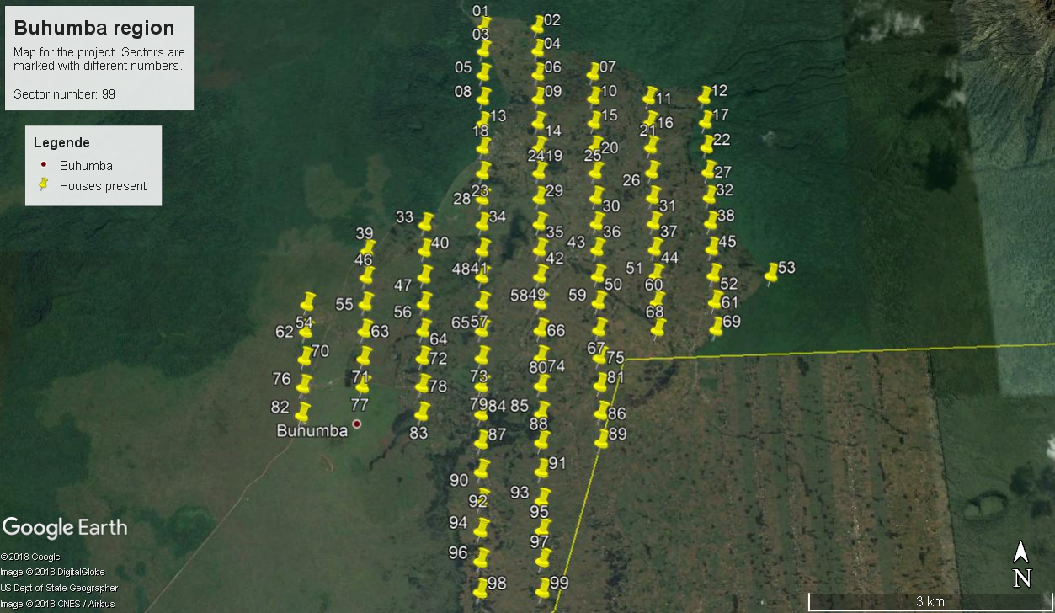Fig 1: Example of placemark placement in Google Earth for 99 sectors.
Using Google Earth, mark the region of interest with placemarks (colored pins with different shapes) sequentially and rename them in order of sectors (e.g., 01, 02, 03, etc). These will save time and trouble when extracting the coordinates in R later on. Then, save these positions (“My Places” in English; “Meine Orte” in German) as a KML file in Google Earth. This is the standard file path for saving coordinates in this program.

Notice that it is important to select sectors in order and to place them on the map as a matrix with regular distances vertically and horizontally. The standard distance I used was 0.003255 for latitude (decimal grades; vertical distance between two placemarks), and 0.006875 for longitude (horizontal distance between two placemarks). If points are too far, information will be lost, but if they are too close, the maps (sectors) will overlap and you may incur into problems by identifying places more than once.

Step 2: extracting coordinates and downloading maps in R
(r_script_extractor.R)

The coordinates should then be extracted, so that only the information on the sector number, longitude and latitude are stored as a table (the KML file stores many more other information that is not necessary for us). The R scripts created here then load the KML and extract these coordinates accordingly. Next, using special packages in R, download the specific sectors as separate images. This way it is possible to set the zoom and resolution of the maps, which allows us to get maps with relative good definition. Maps are stored as TIFF images and R objects for later use in R. Bare in mind that the coordinates first selected will be the exact location of the center of the downloaded maps.

Step 3: combine maps in Inkscape
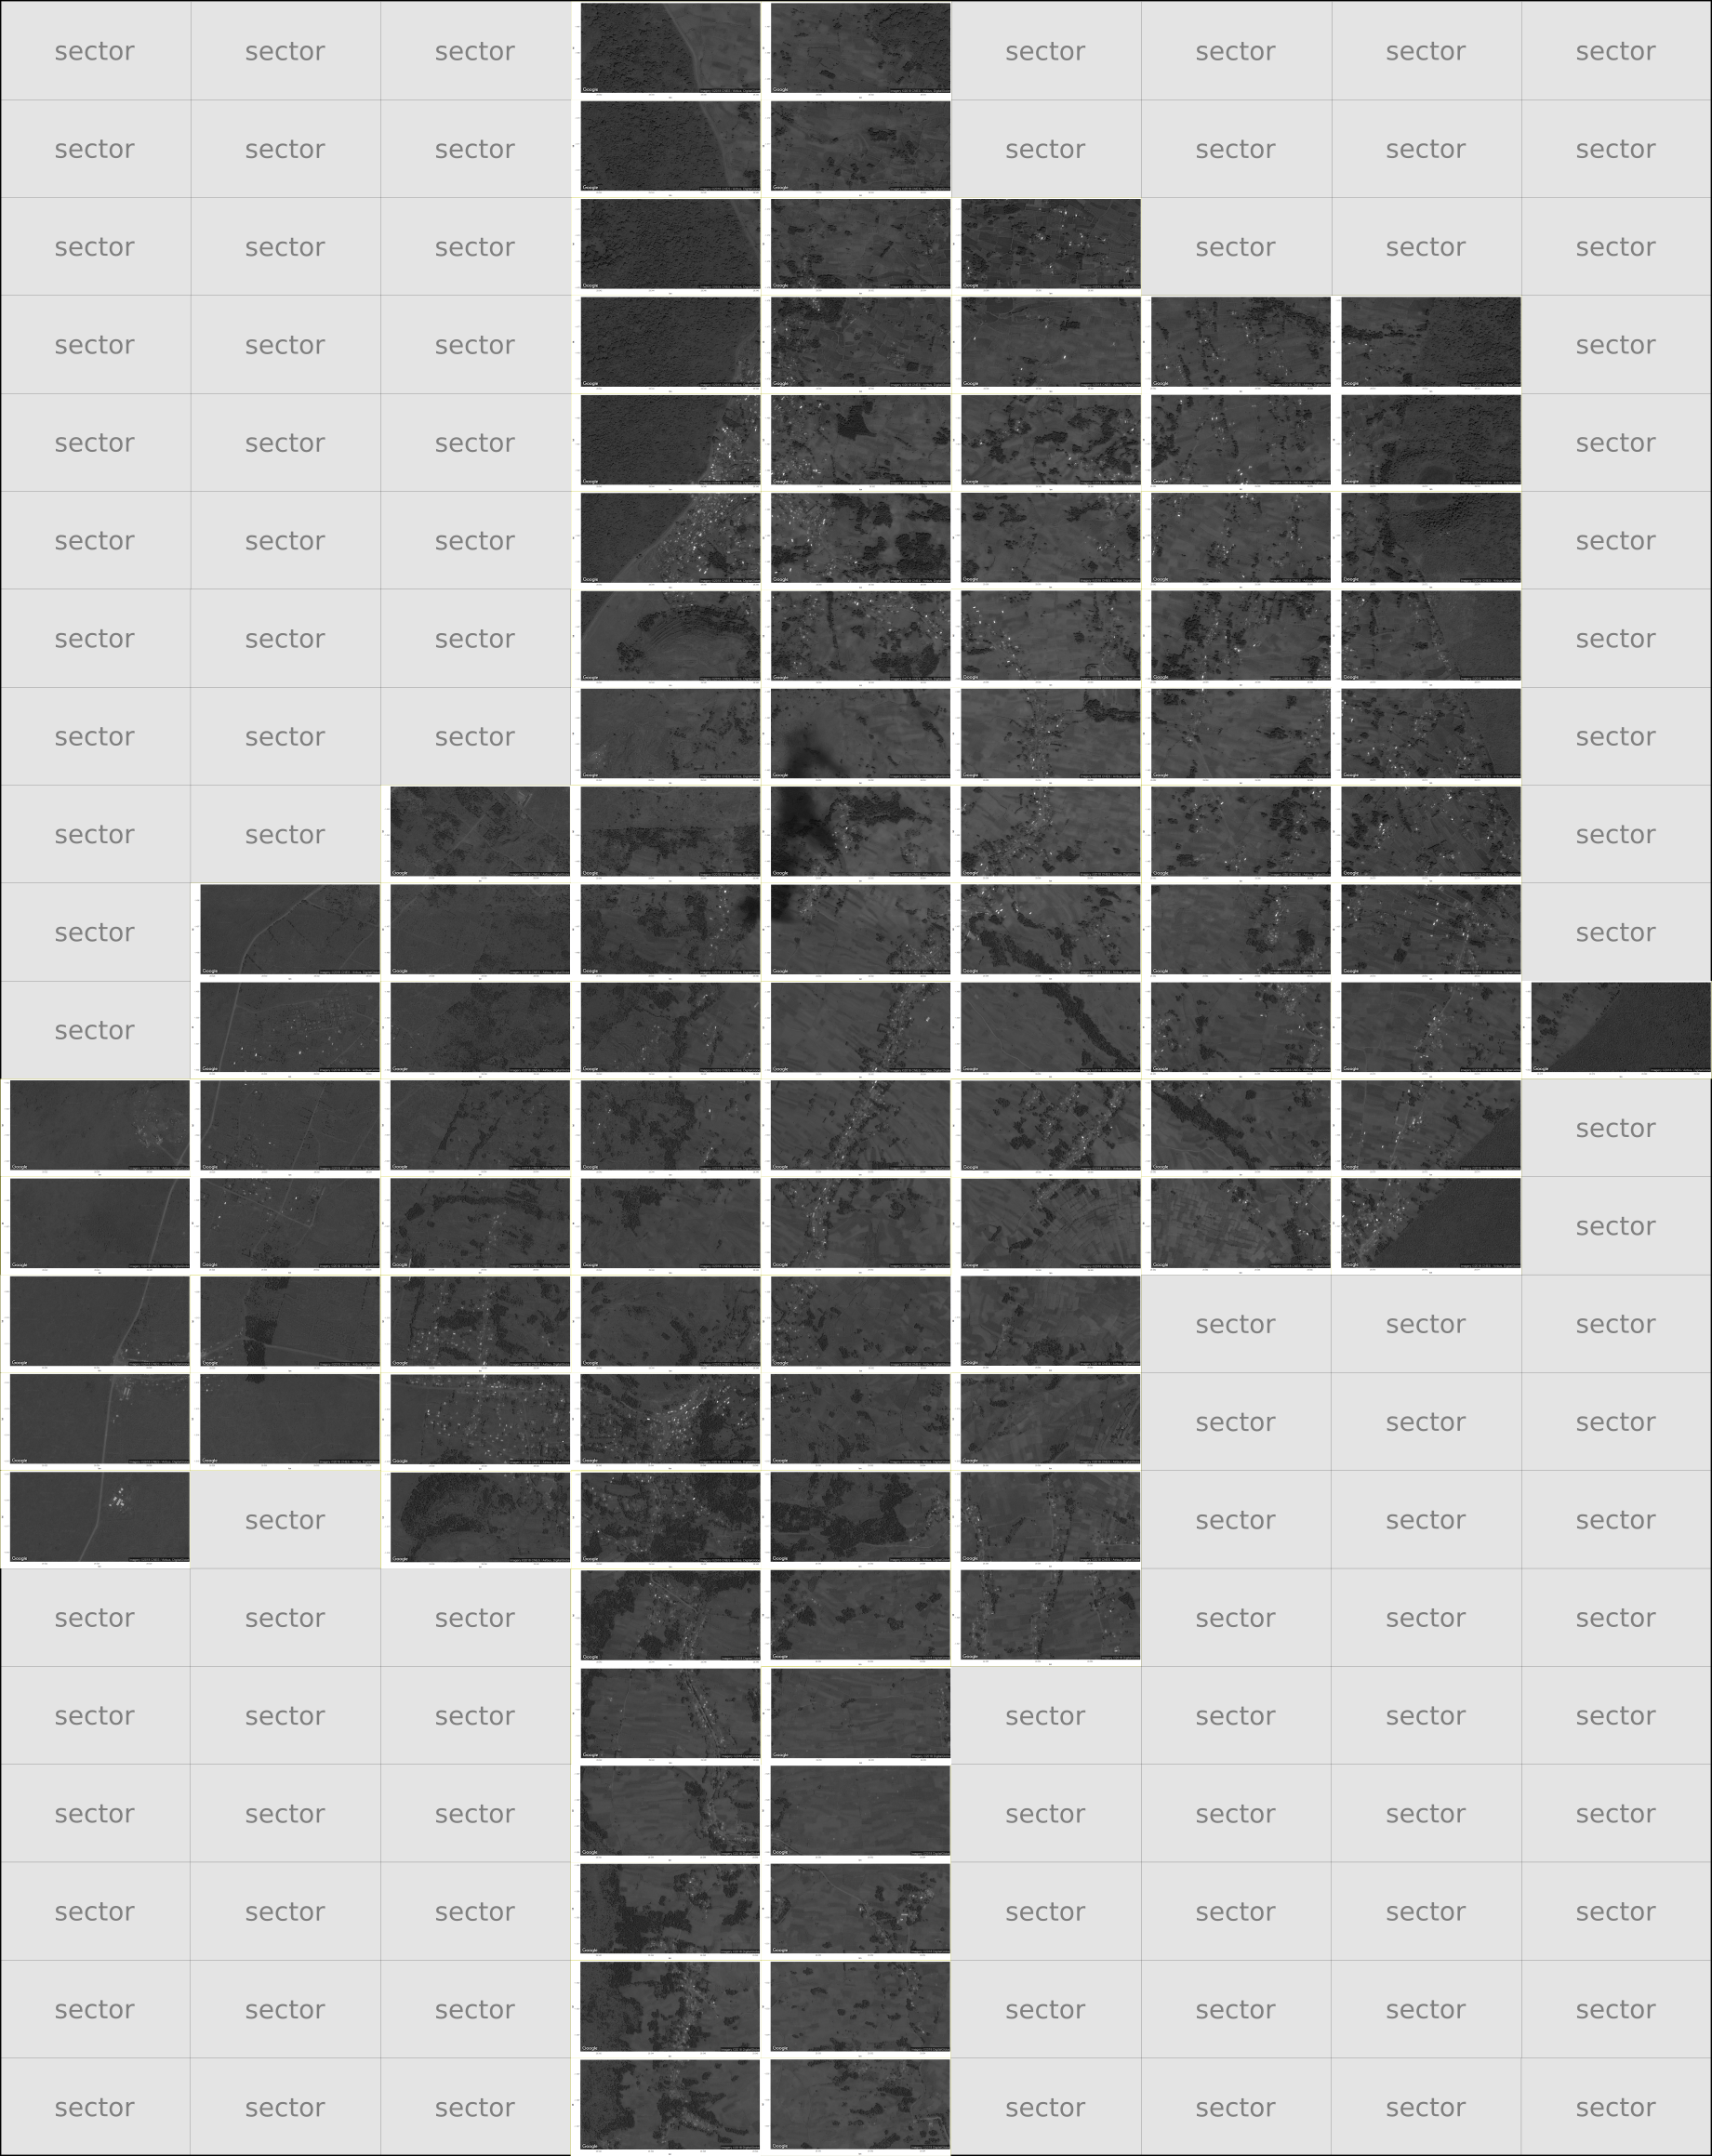Fig 2: Example of image combining all sectors made in Inkscape. Zooming is possible without loosing picture quality.
Using an image/vector editor (Inkscape) it is possible to combine all sector images into one large map unit. This is helpful, because it may be set with different layers and selecting the maps of interest is very easy. Zooming in might not imply in loosing quality of the pictures.

Step 4: manually selecting the units for randomization
For each particular sector of interest, manually recognize, identify and assign IDs (unique numbers or codes that identify a particular unit) for the sampling units to later randomize. Make a list and ideally place those IDs in the big map (see step 3) in a different layer at the file image.

Step 5: randomize samples in R
(r_script_randomizer.R)

Assuming that you made a power analysis, or that you know exactly how many samples are needed for the study, select the sample size (n) and the total number of units that were identified to be potential used in the study (N). Produce a random sample of n size from the population of points marked in the map. This randomization may then be saved as a text file for further use.
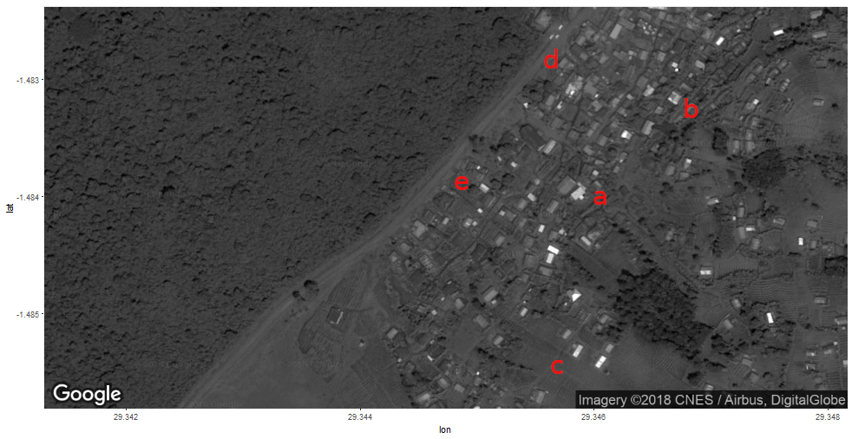Fig 3: Example of sector showing labeled landmark that are identified in red for randomization. Note that letters were used to identify landmarks. The center of the map is the coordinate selected in Google Earth for this particular sector.

